Image negative:

a = imread("cameraman.tif");

subplot(1, 2, 1),

imshow(a);

title("Original image");

L = 2 ^ 8;

neg = (L - 1) - a;

subplot(1, 2, 2),

imshow(neg);

title("Negative Image")

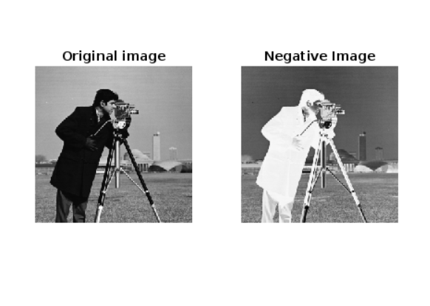

Contrast stretching:

I = imread('pout.tif');

figure

subplot(1, 2, 1),

imshow(I)

title('Original Image')

J = imadjust(I, stretchlim(I), []);

subplot(1, 2, 2),

imshow(J)

title('Adjusted Image')

